**SNAKE GAME USING LINKED LIST**

*BY:SUVARNA LAKSHMI*

*20BDS0322*

**MY ROLE:**

I am doing this project alone. So most of the coding part is done by me .

**WHAT I LEARNED:**

While doing this project I learned how to install libraries which is required for building snake game.I have used C++ to build this project. To use list I have included template library list in my project. It is very interesting to build a game and coding part was super fun.

**COURSES TAKEN:**

I have not taken any courses for doing this project but referred some youtube and github repos to do this project.

**HEADER FILES INCLUDED**

* Iostream
* Windows
* Conio
* Stdlib
* fstream

**WORK FLOW**

1. First all the header files are included that is required for this project
2. All the variables are initialised that represent the direction of the snake
3. Boundaries are set up for playing this game
4. The food is also made to appear in randomn place
5. Controls from user is taken according to AWSD
6. If the player is lost the message is printed

**SCREEN SHOTS**

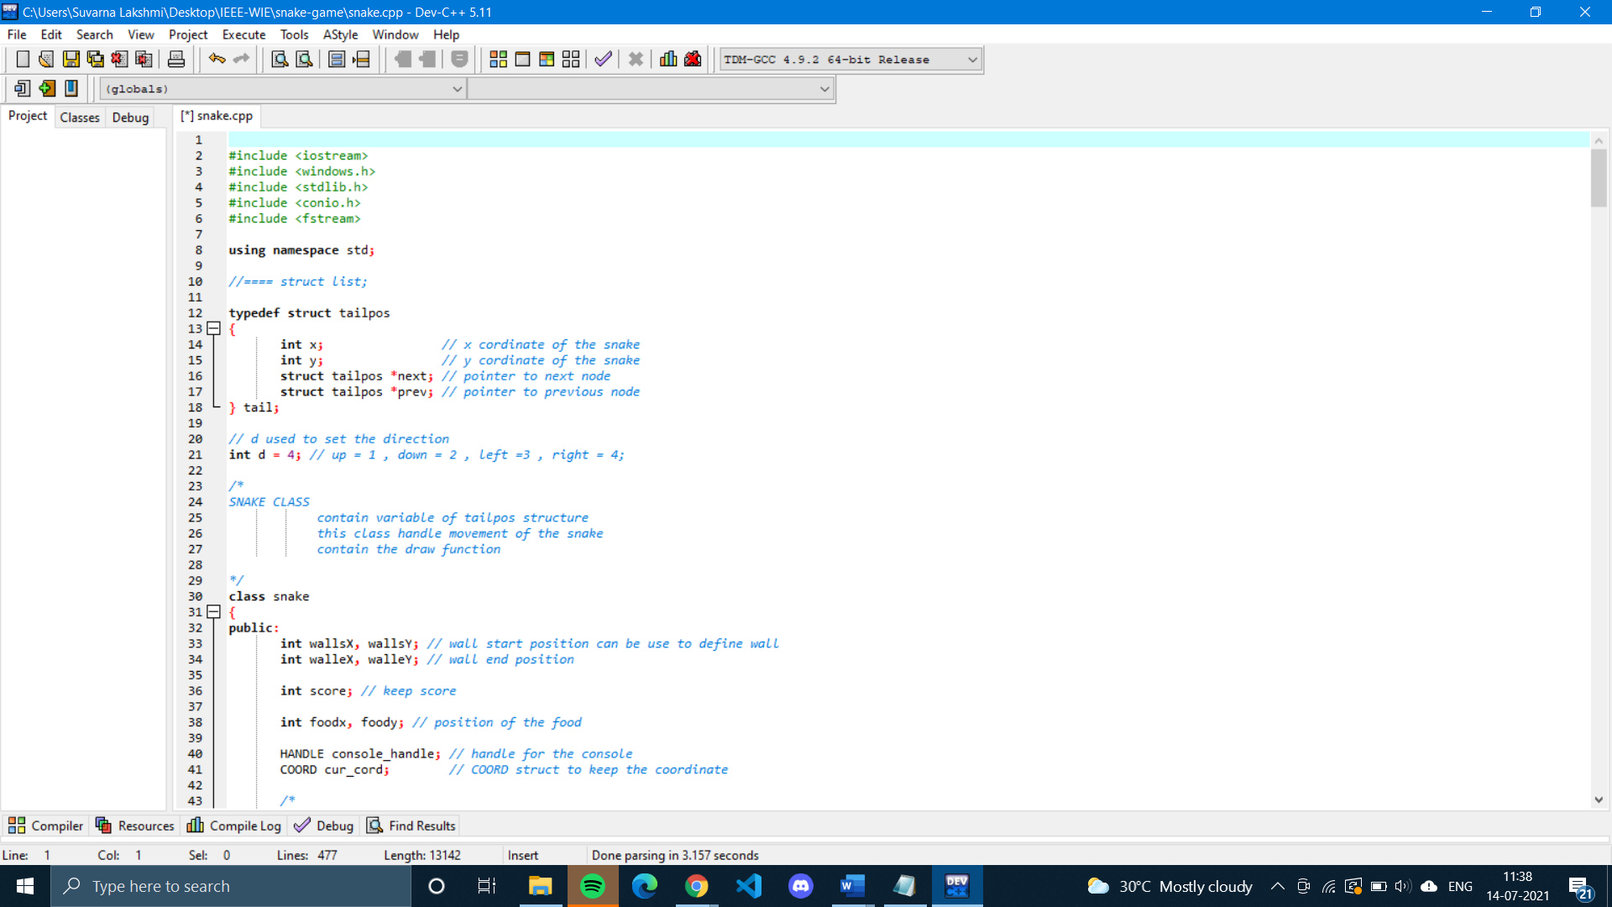

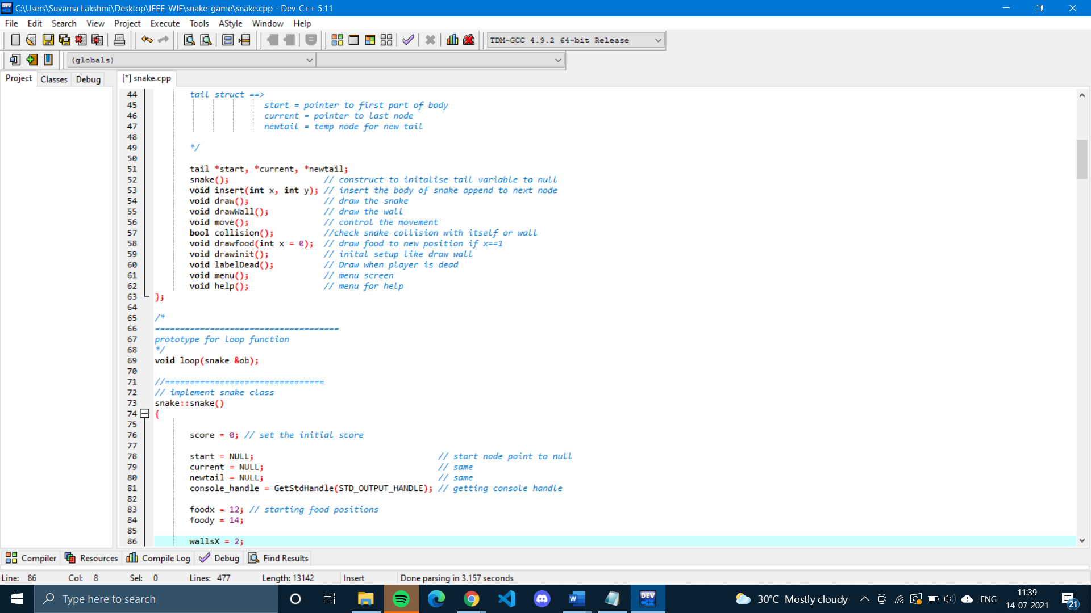

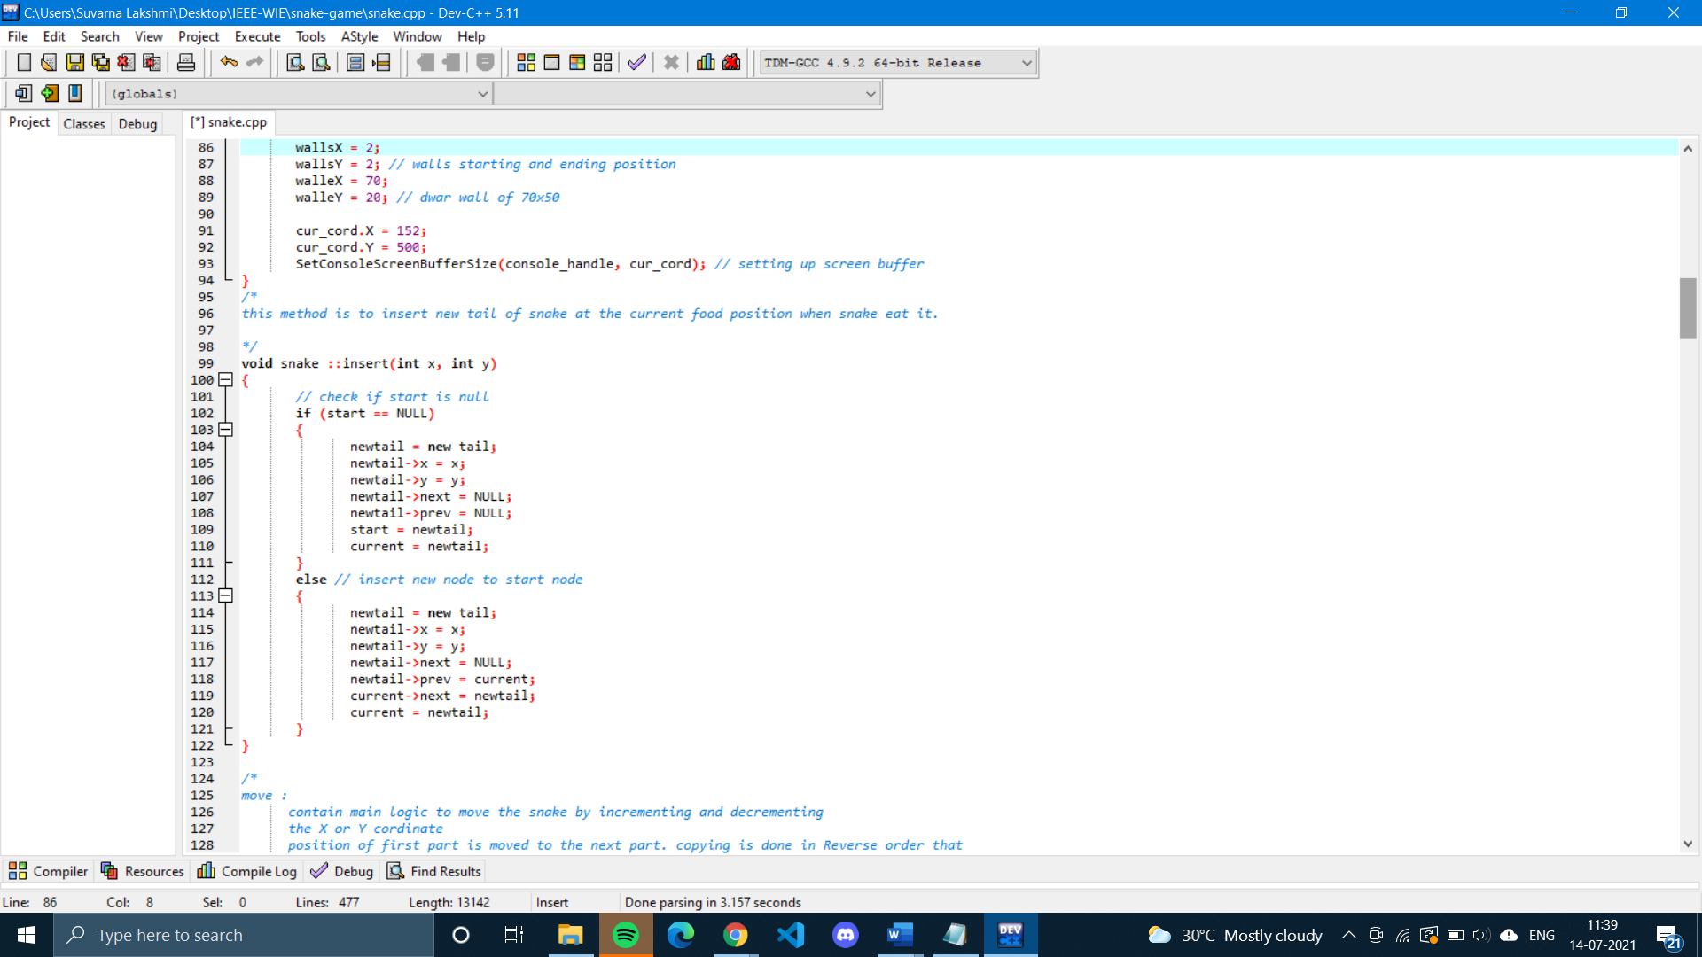

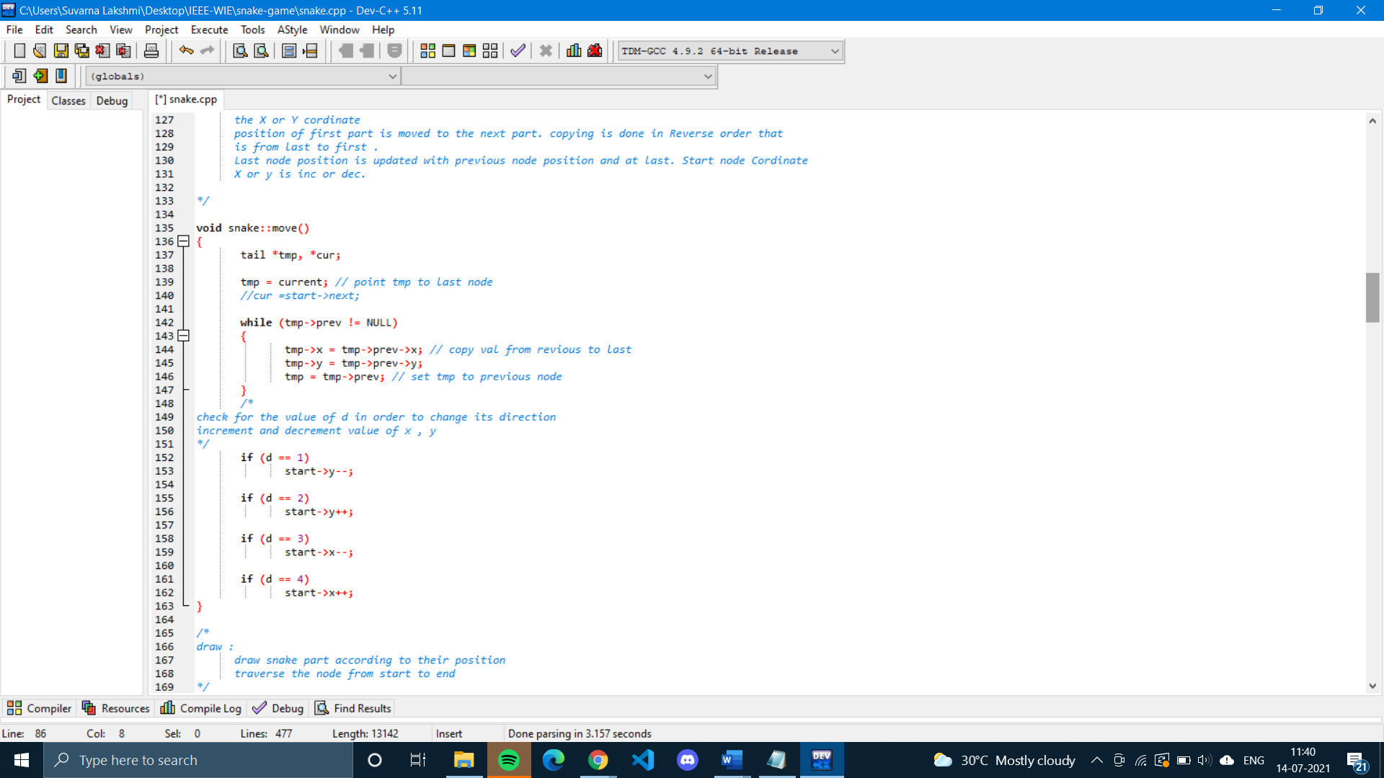

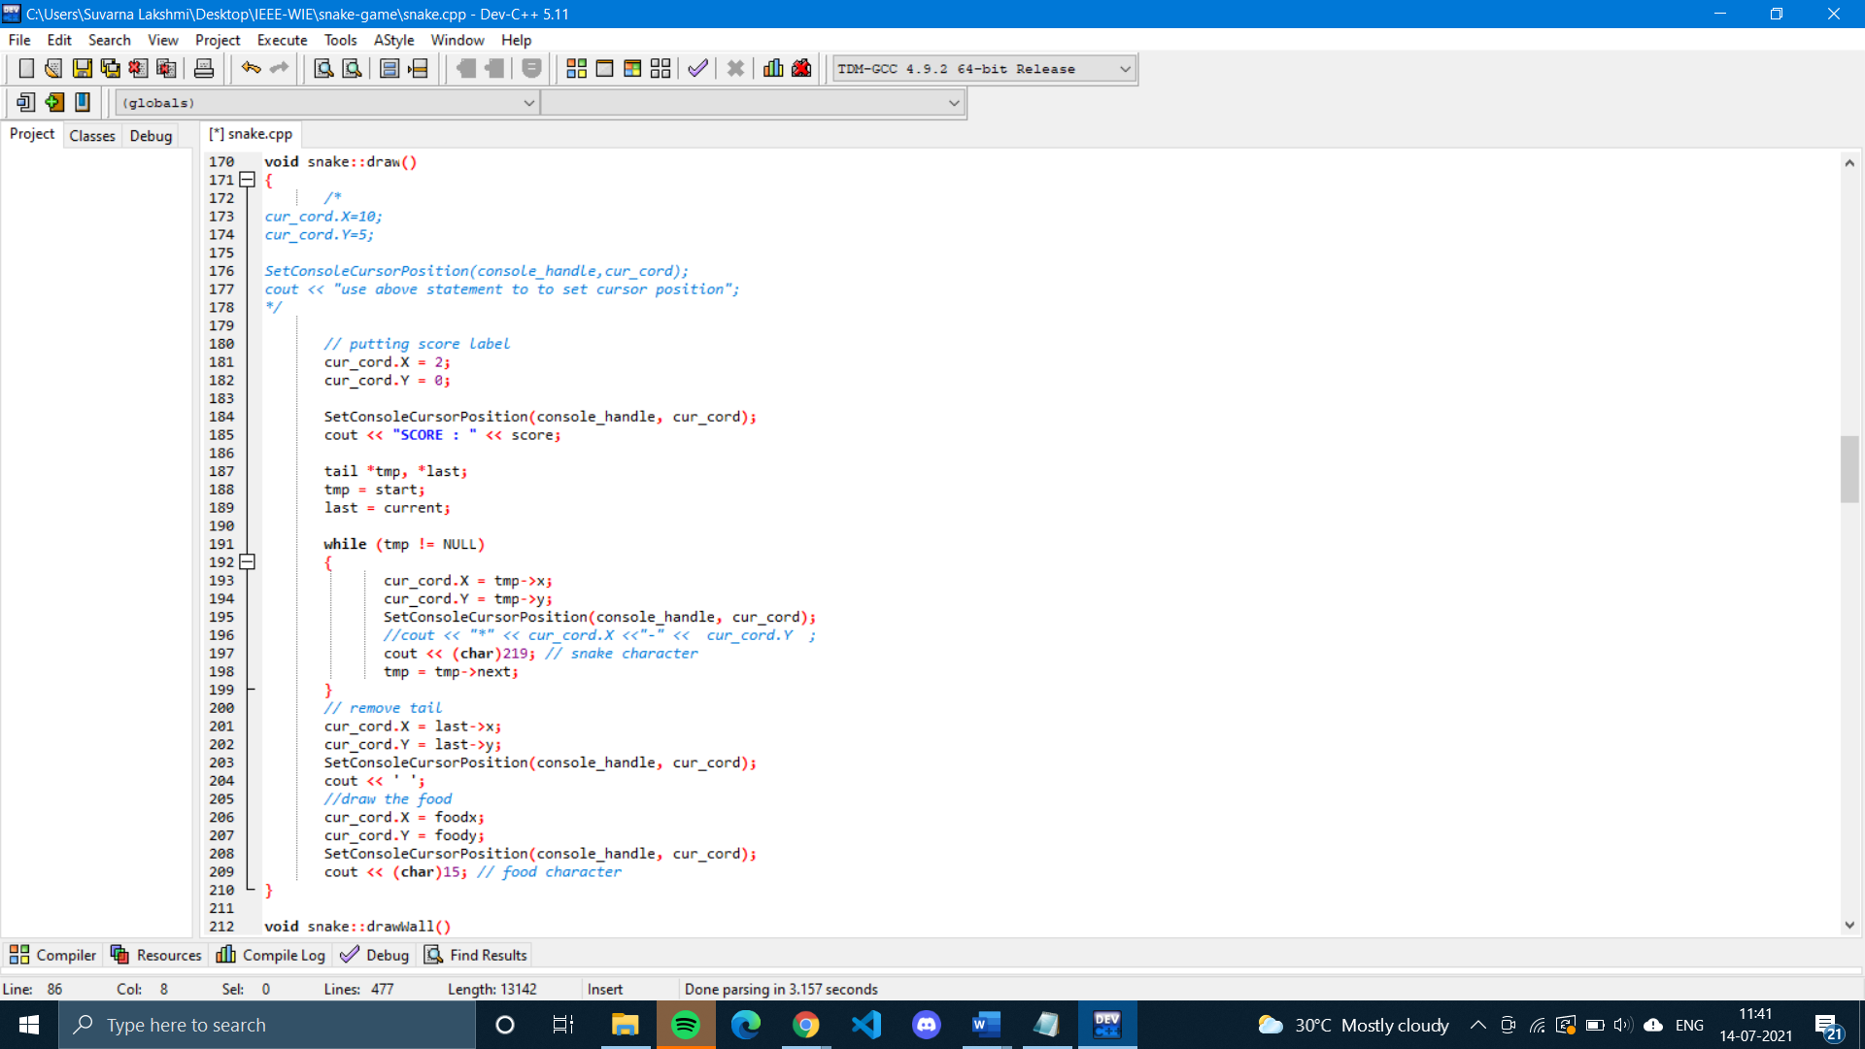

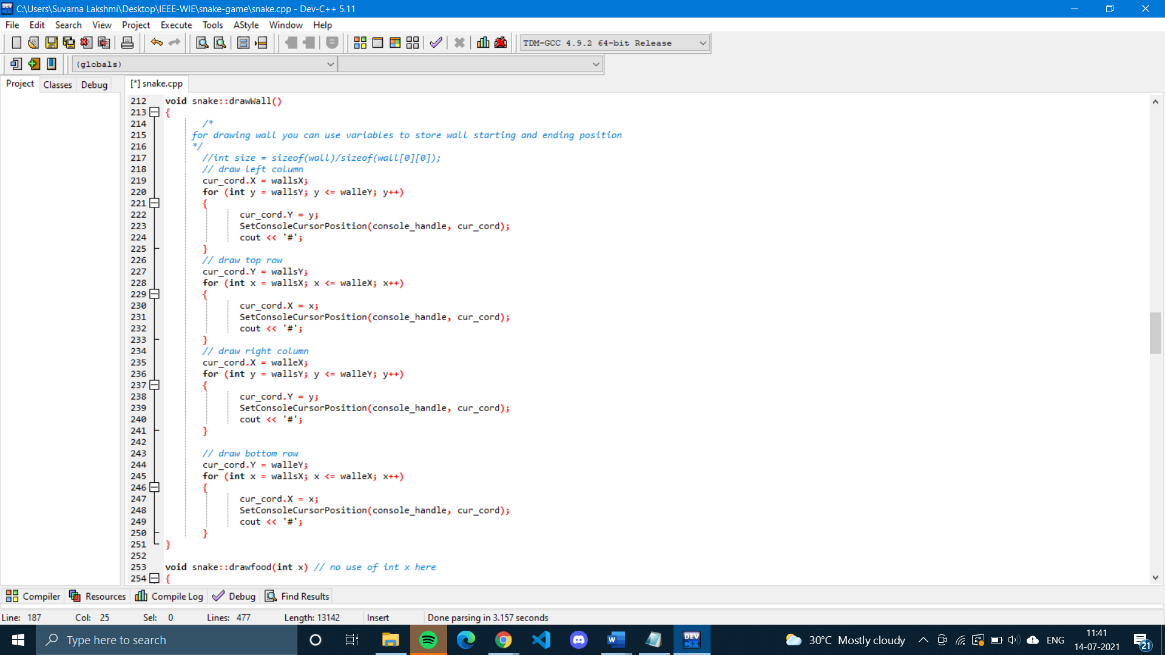

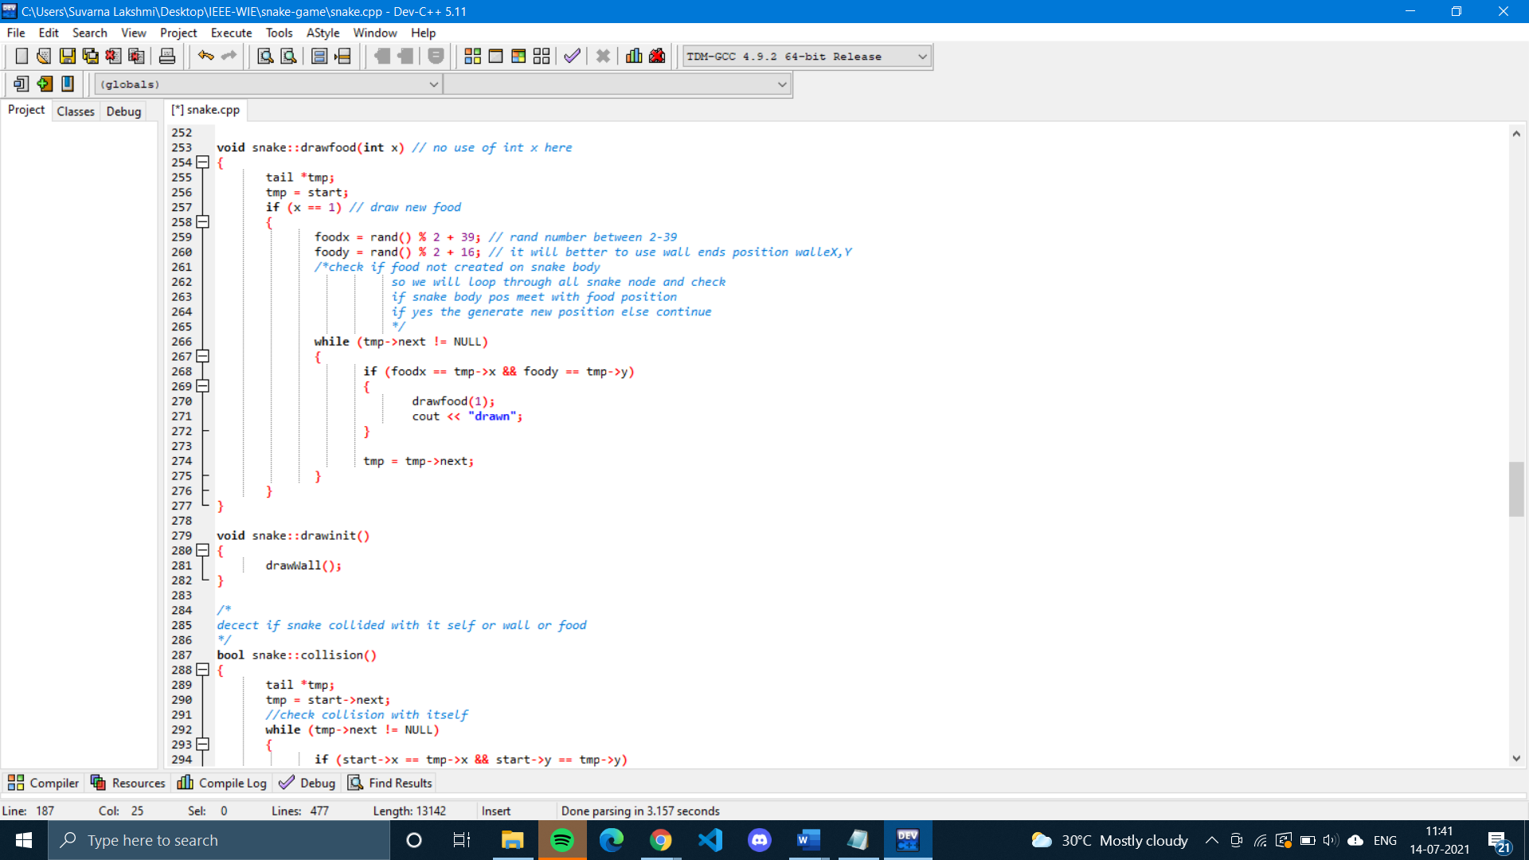

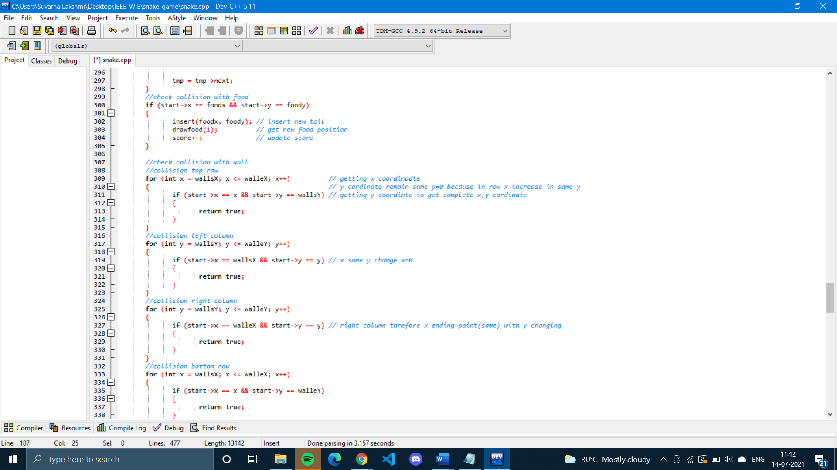

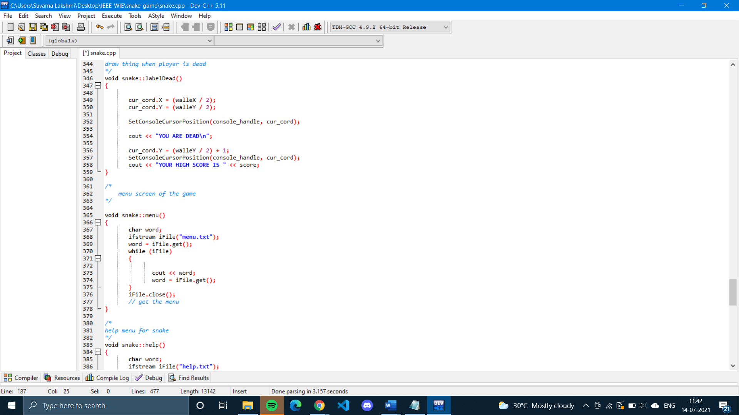

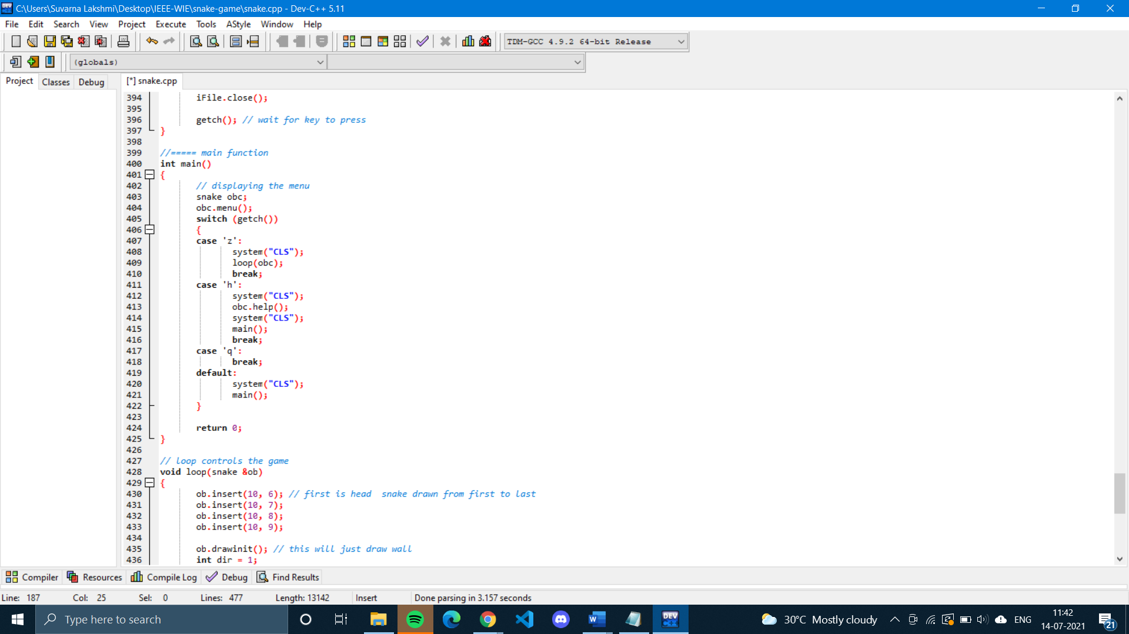

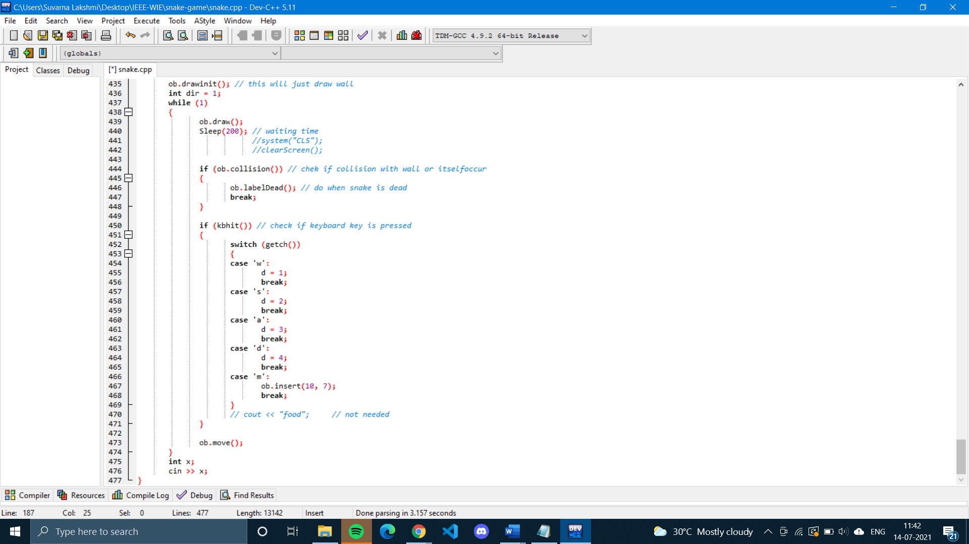

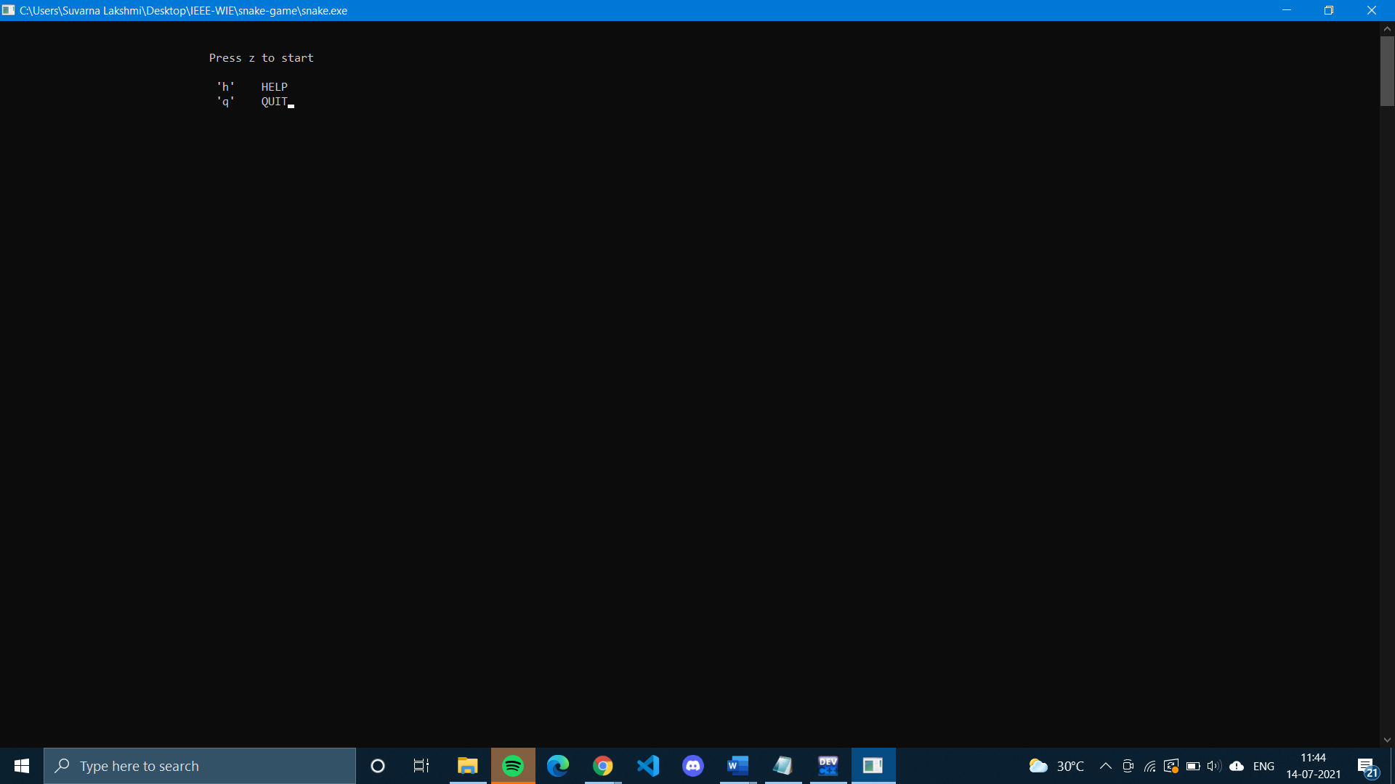

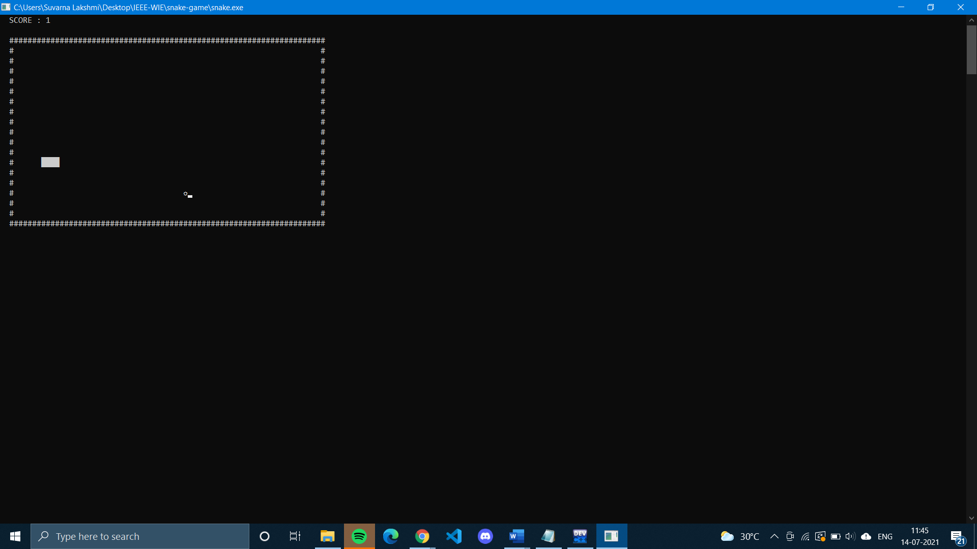

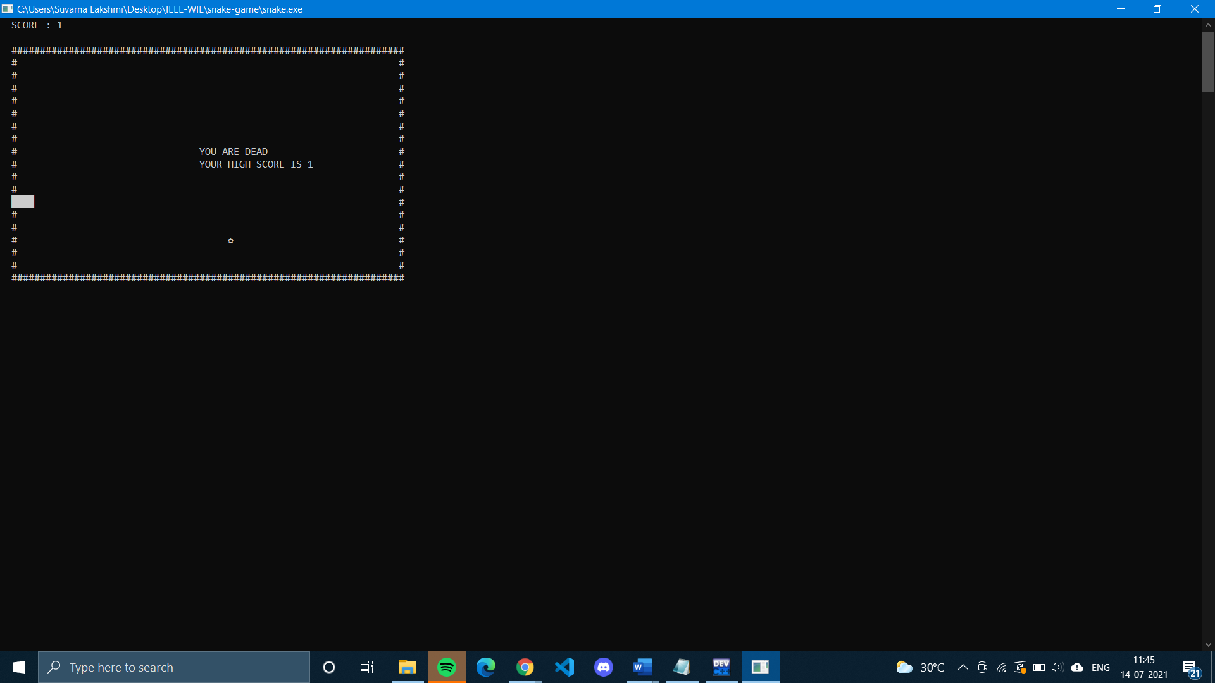

**GITHUB REPO LINK:**

https://github.com/suvarna-13/Snakegame_wie_2Project